CHAPTER 9: Energy transmission
Worksheet 9.7

Communications
Science Quest 9: pages 331–3
Student: Class:

Transmitting radio waves
1. The following diagrams show how audio radio waves are combined with carrier waves in order to be transmitted.
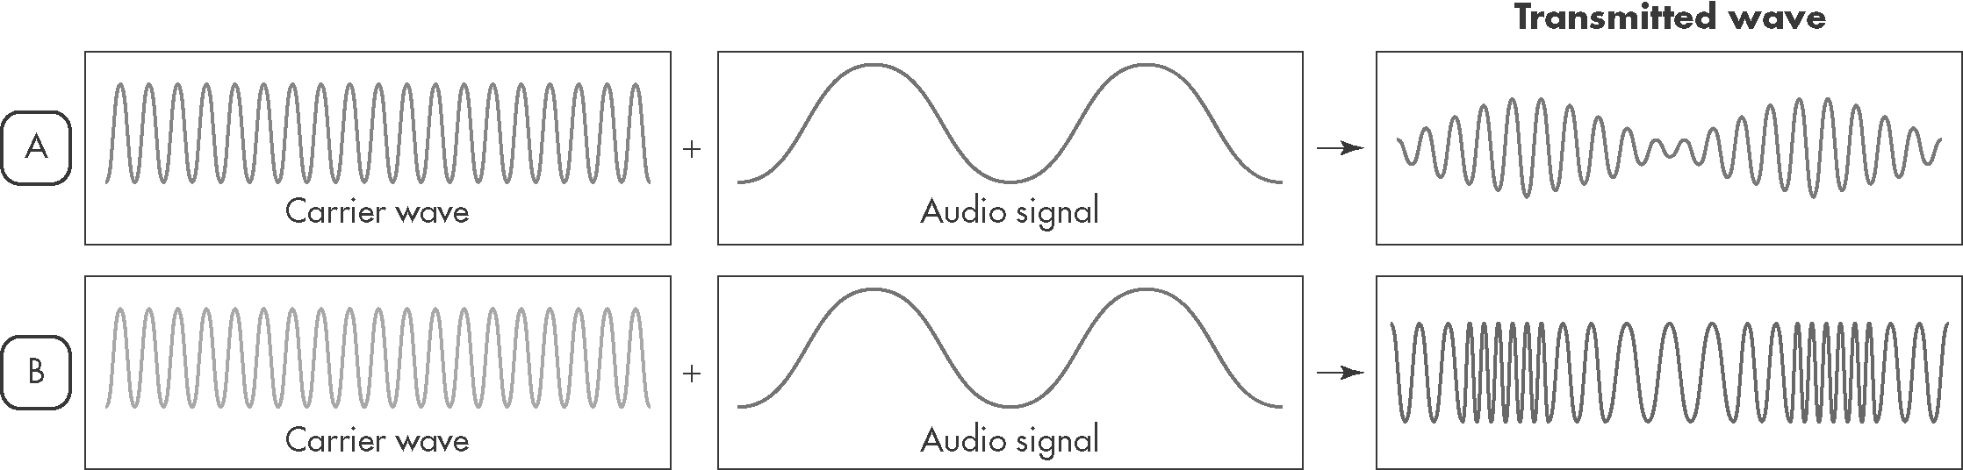
Identify which method corresponds to FM and which corresponds to AM transmission.
FM: ...................................... AM: ......................................

Optical fibres
2. The following diagram shows a light ray moving through a section of optical fibre.
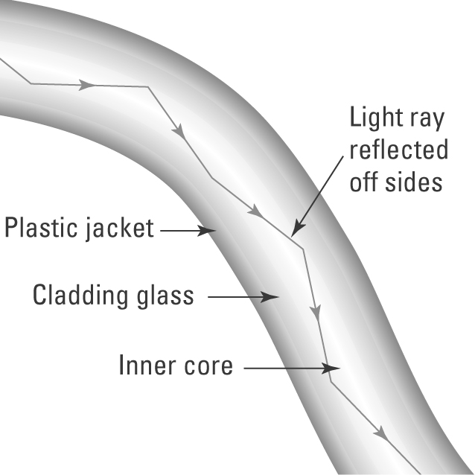 | (a) Name the process that allows the ray of light to be transmitted through the fibre.  (b) Explain the purpose of the ‘cladding glass’.
(c) Explain how optical fibres are used in communication networks.

CHAPTER 9: Energy transmission
Worksheet 9.7

Page 2

Communication networks
3. Consider the following photographs.
A | B
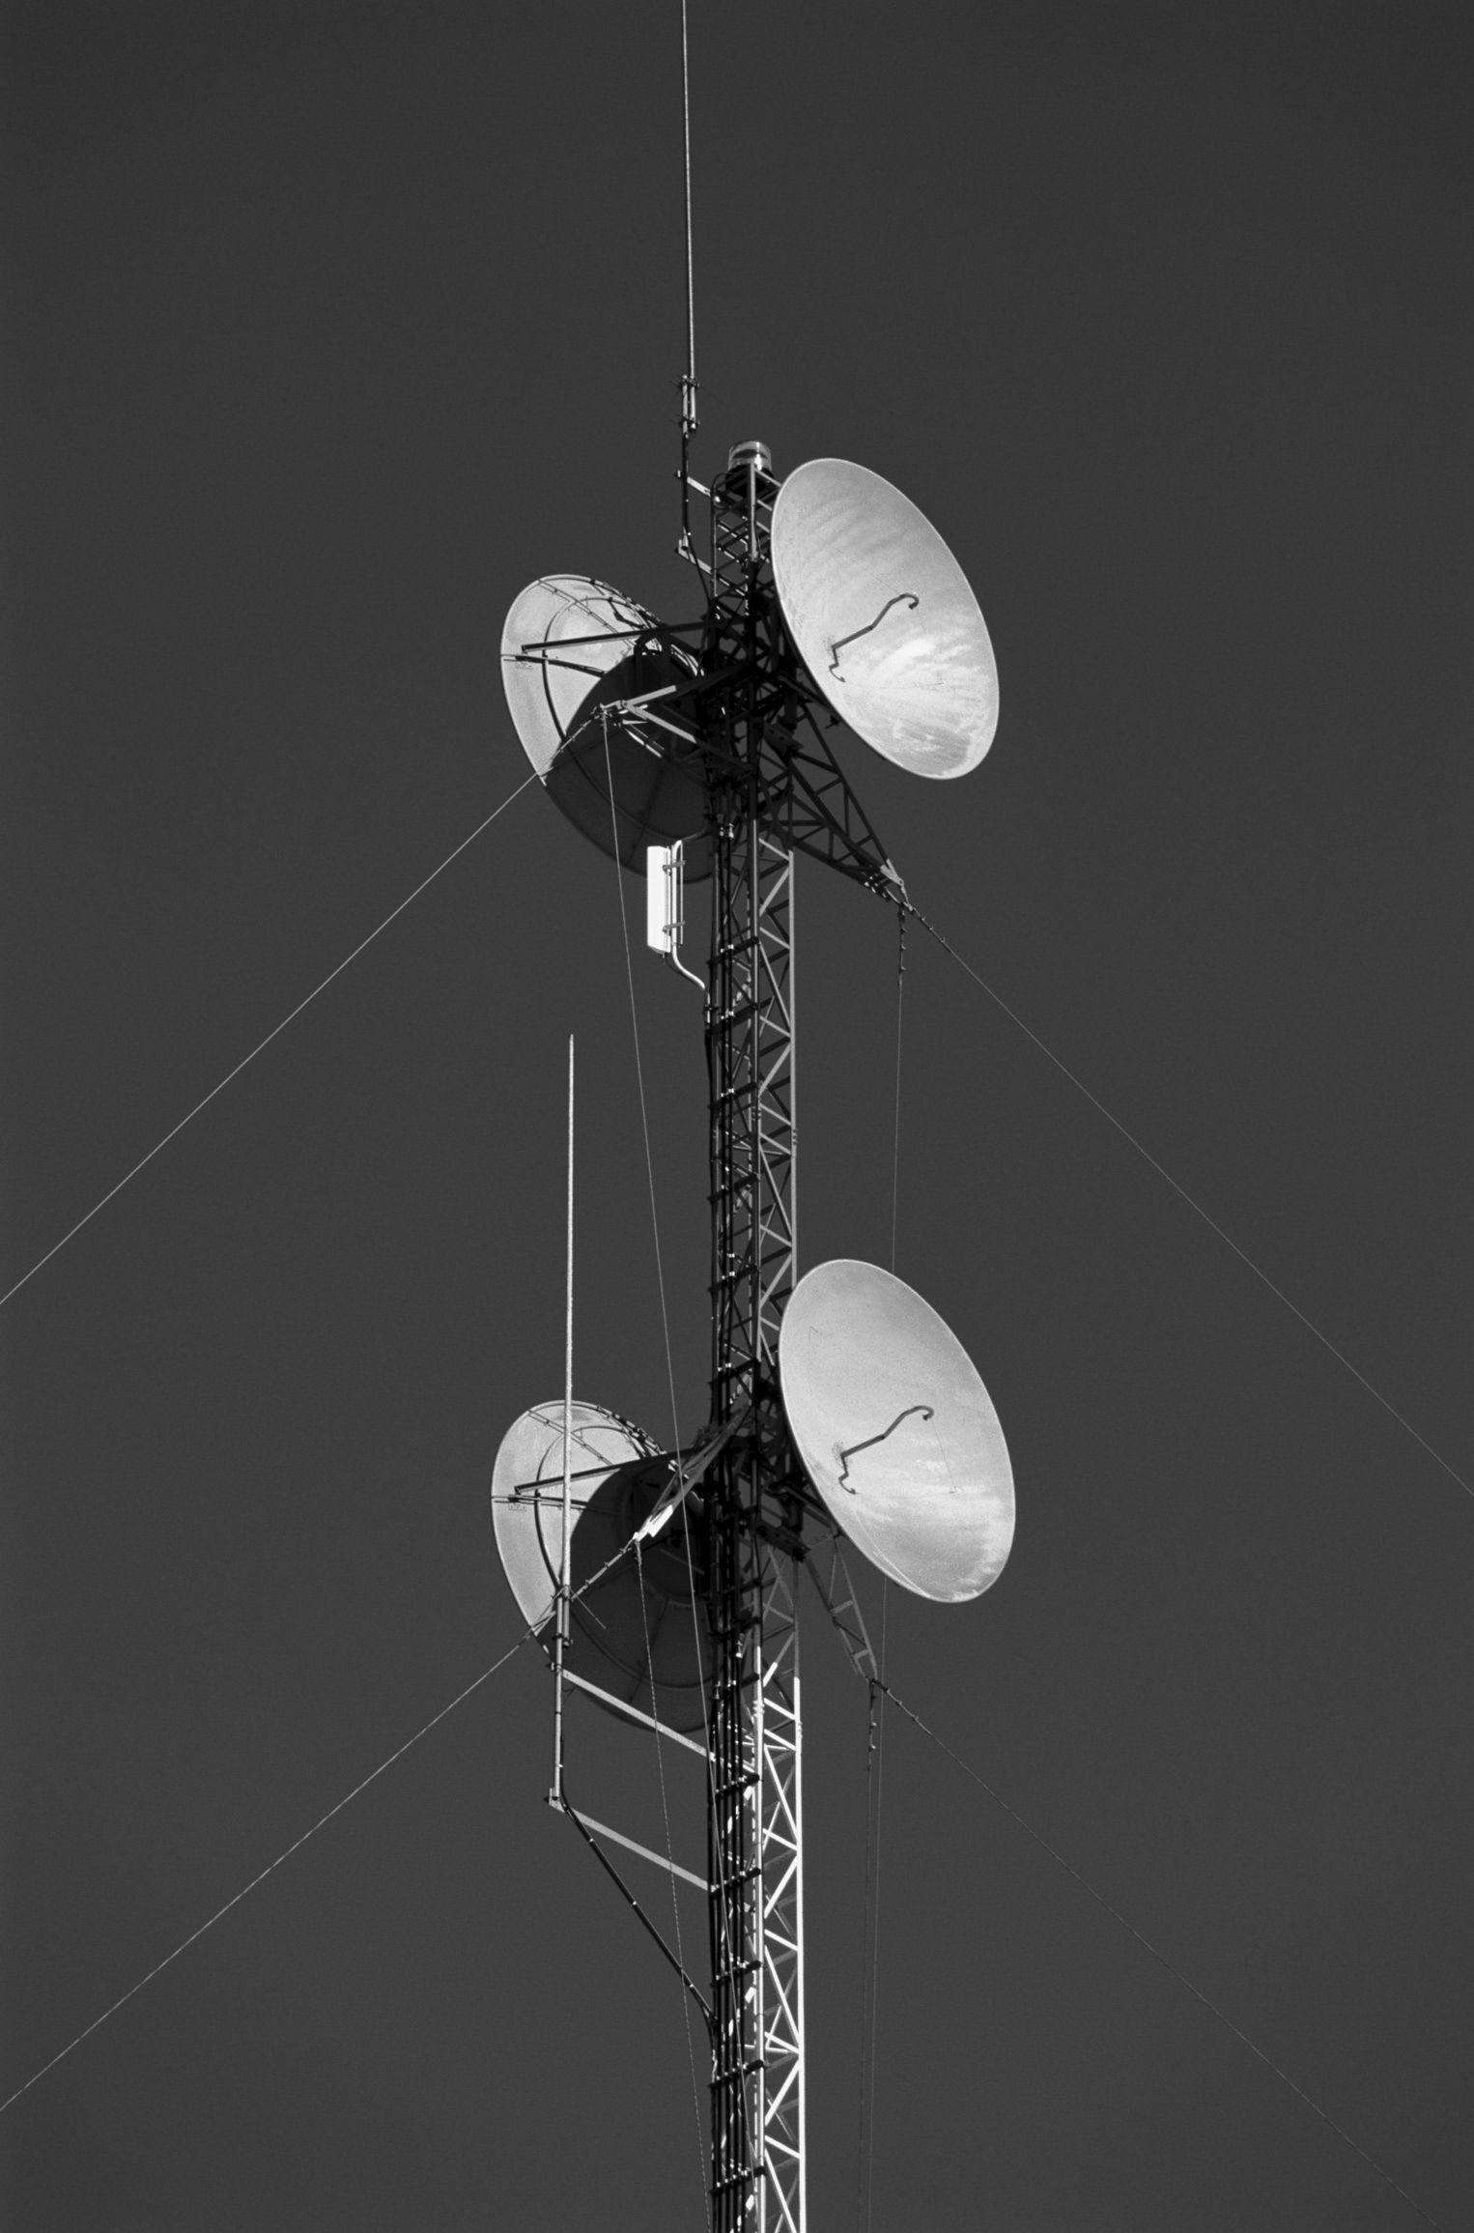 | 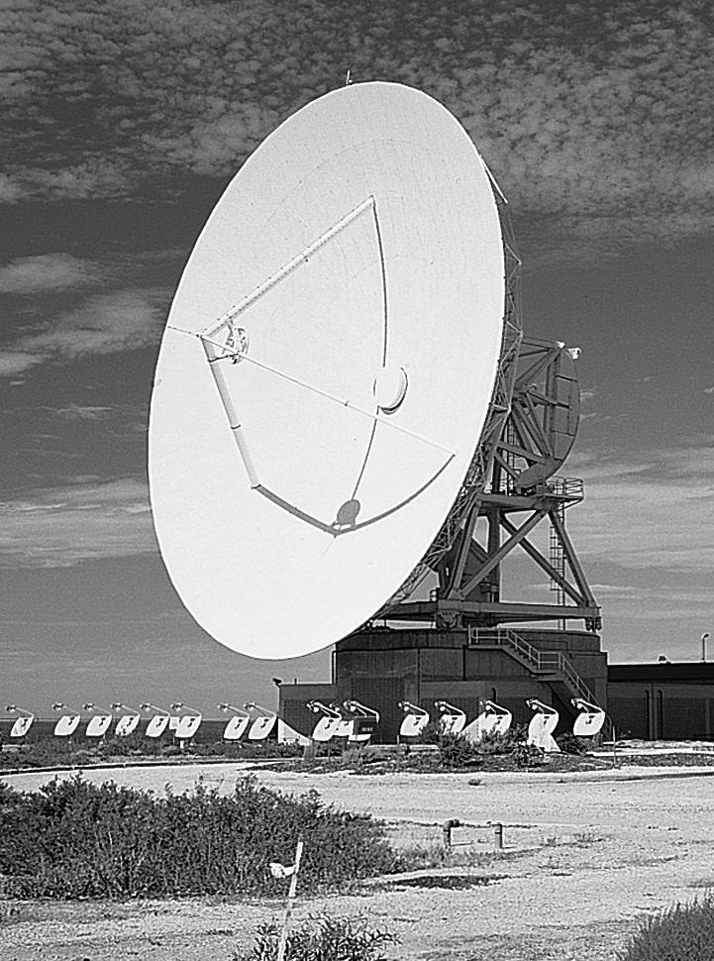

(a) Photograph A shows a microwave repeater station. Explain the purpose of these structures in our communication networks.

(b) Photograph B shows a large dish antenna. Explain the purpose of this structure in our communication networks.

